Imagine that you have discovered a new species. Write about your discovery for a wildlife magazine for children. Using this writing prompt, you could either write about the Tongo Lizard, or a made-up creature of your own imagination.
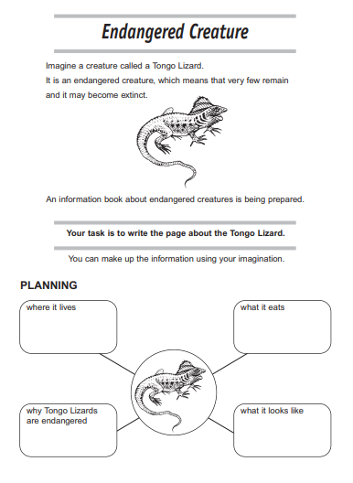
Include information linked to your science work on classification e.g. Is it a vertebrate? Mammal, reptile? Cold-blooded? Has feathers, scales? Etc. Consider how to engage your readers and how to present your information in an interesting way.

