

CORE LEANING TASK FOR ENGLISH

The story we are going to be having a look at the story of ‘The Scarecrows Wedding’ by Julia Donaldson. If you have the story have a read or follow the link to watch it read to you.

<https://www.youtube.com/watch?v=UIHLnnJ-uFc>

In the story they write a list of things for the day. Listen carefully to the story and write them down. Now, add any other things you think they will need for the wedding.

PHONICS

We have sent home some phonics guidance booklets to help you to continue to work with your child on their phonics.

Teach Practise Apply

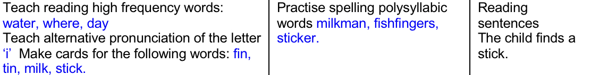

Please use this link to Ash’s phonics on the espresso website.

<https://central.espresso.co.uk/espresso/primary_uk/home/index.html>

KEEPING IN TOUCH

If you have any questions or queries regarding remote learning tasks, please contact your child’s class teacher through the email address below.

We invite you to submit photographs of your children’s experiences and photographs of completed paper based tasks to:

[Year1@sherwood.lancs.sch.uk](mailto:Year1@sherwood.lancs.sch.uk)

CORE LEARNING TASK FOR MATHEMATICS

This weeks topic continues to be addition. Please use a dice to generate addition calculations. Start by rolling the dice 3 times to make a 2 digit number add a 1 digit number ( 23 + 5=). Remember you can use equipment to help you.

Then you can roll the dice 4 times to make a 2 digit add a 2 digit number calculation ( 32 + 12=).

If you can’t find a dice then follow the link for your own virtual course.

<https://eslkidsgames.com/classroom-dice>

Please complete the challenges that have been set on Mathletics before having a go at the other addition challenges where you can play against other children.

SHERWOOD PRIMARY SCHOOL

YEAR 1 REMOTE LEARNING PLAN

Core Learning Tasks for Thursday 23rd April 2020