Fact file – square-based pyramid.

How many curved edges - 0
How many straight edges – 8
How many curved faces – 0
How many flat faces – 5
What shape faces – 3 triangle 1 square
Does it have vertices – yes
Can it be stacked – no
Can it be rolled – no
Can you identify any example of square – based pyramid in your everyday life – Blackpool tower

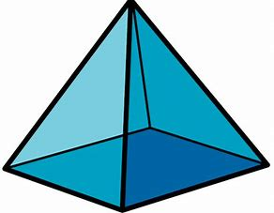

Fact File – Triangular Prism.

How many curved edges - 0
How many straight edges – 9
How many curved faces – 0
How many flat faces – 5
What shape faces – 2 triangle 3 rectangle
Does it have vertices – yes
Can it be stacked – no
Can it be rolled – yes
Can you identify any example of triangular prism in your everyday life – folder

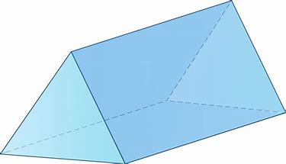

Fact File – Pentagonal Prism.

How many curved edges – 0
How many straight edges – 15
How many curved faces – 0
How many flat faces – 7
What shape faces – 2 pentagons 5 squares
Does it have vertices – yes
Can it be stacked – yes
Can it be rolled – yes
Can you identify any example of pentagonal prism in your everyday life – drum
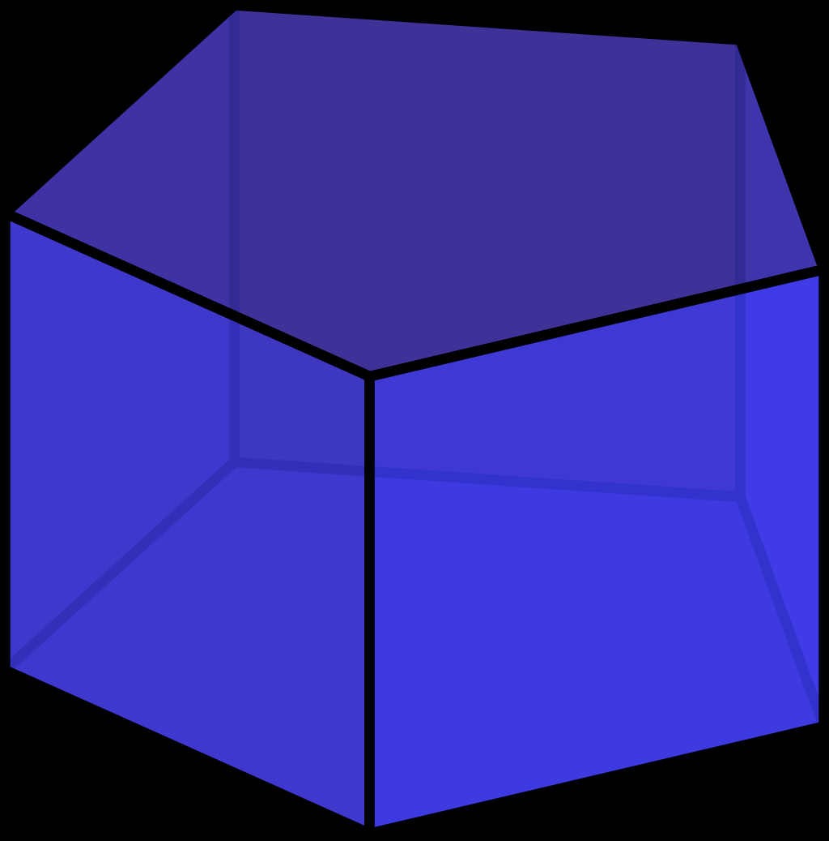

TETRAHEDRON

How many curved edges – 0
How many straight edges – 6
How many curved faces – 0
How many flat faces – 4
What shape faces – 4
Does it have vertices – yes
Can it be stacked – no
Can it be rolled – no
Can you identify any example of tetrahedron in your everyday life – Toblerone box.

