Times Table Challenge
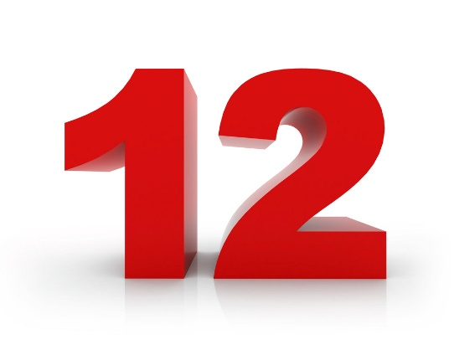

Stage 1 -
https://mathsframe.co.uk/en/resources/resource/477/Multiplication-Tables-Check
Full marks- 25 questions and 10 seconds per question.

Stage 2 -
https://www.timestables.co.uk/diploma/
40/40 in under 7 mins to achieve your diploma.

Stage 3-
A question from Mrs Lumb!

Stage 4
Wear your 12 badge with pride! 🙂

