Tuesday 26th January
What is the land used for in the Ribble Valley?

Please log into Digimaps and zoom into the Ribble Valley area. Click on the on the key on the left hand side to explore some of the Ordnance Survey symbols.
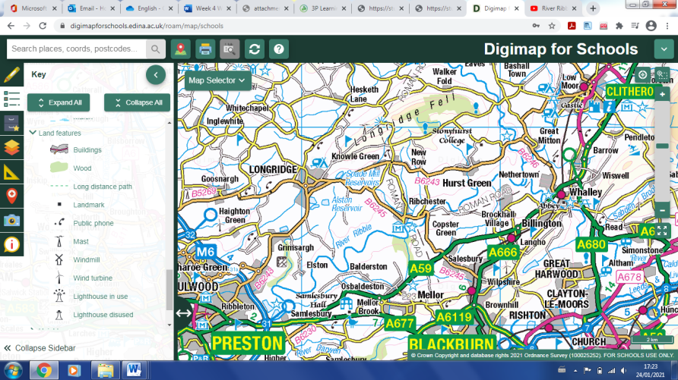

Draw and label five symbols you can find on the map of the Ribble Valley:

Watch the journey of the River Ribble from sea to source:
https://www.youtube.com/watch?v=ApcdUzoX_AU
What does the video tell us about the land around the River Ribble and what it is used for?
_____________________________________________________________________________________________________________________________________________________________________________

Go on Google Earth and have a look at the land around the River Ribble. Can you find any more features or ways in which the land is used? Please record any human or physical features you can find.

Human:
________________________________________________________________________________________________________

Physical:
________________________________________________________________________________________________________

